PRACTICAL-4
OBJECTIVE – CREATE AN AWS LAMBDA FUNCTION
1. Log in to AWS Management Console
- Go to AWS Console.
- Sign in with your credentials.

2. Navigate to AWS Lambda
- In the search bar, type Lambda.
- Click on Lambda service.

3. Create a New Lambda Function
- Click Create function.
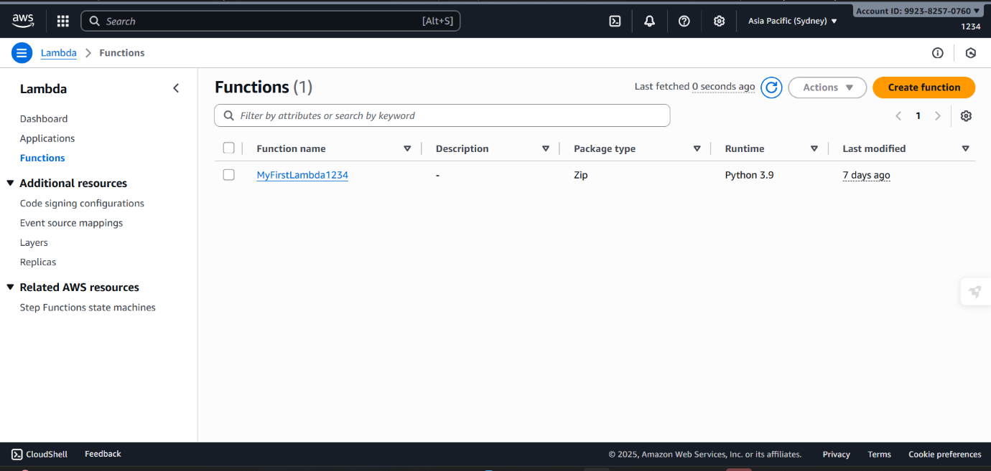

4. Choose a Creation Method
You’ll see 3 options:
- Author from scratch → (most common, start fresh).
- Use a blueprint → predefined templates.
- Container image → deploy code as Docker container.
Select Author from scratch.

5. Configure Basic Settings
- Function name: Enter a unique name (e.g., MyFirstLambda).
- Runtime: Choose a runtime (Node.js, Python, Java, Go, etc. → example: Python 3.9).
- Permissions (Execution Role):
  - Create a new role with basic Lambda permissions (recommended if you’re new).
  - Or choose an existing IAM role if you already have one.
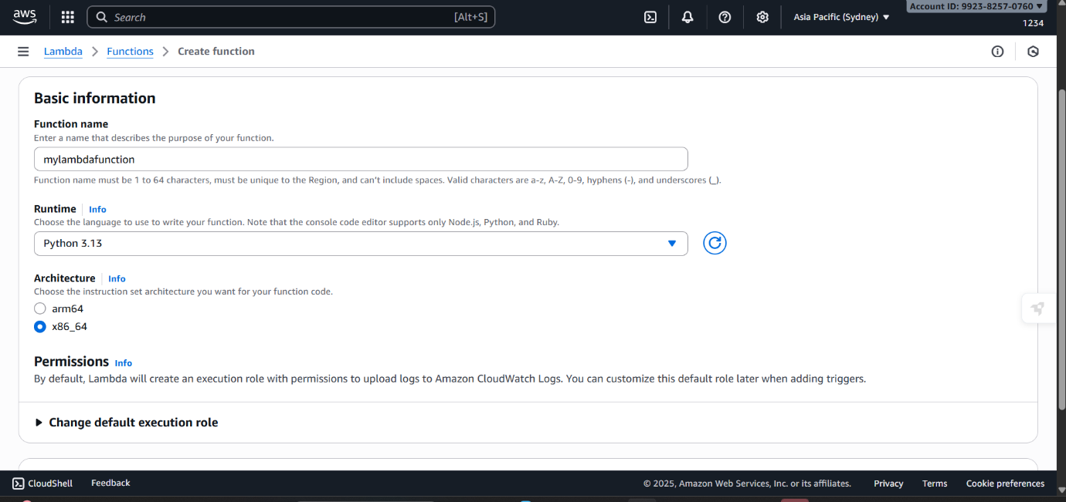

6. Click Create Function
- Wait a few seconds while AWS provisions the function.
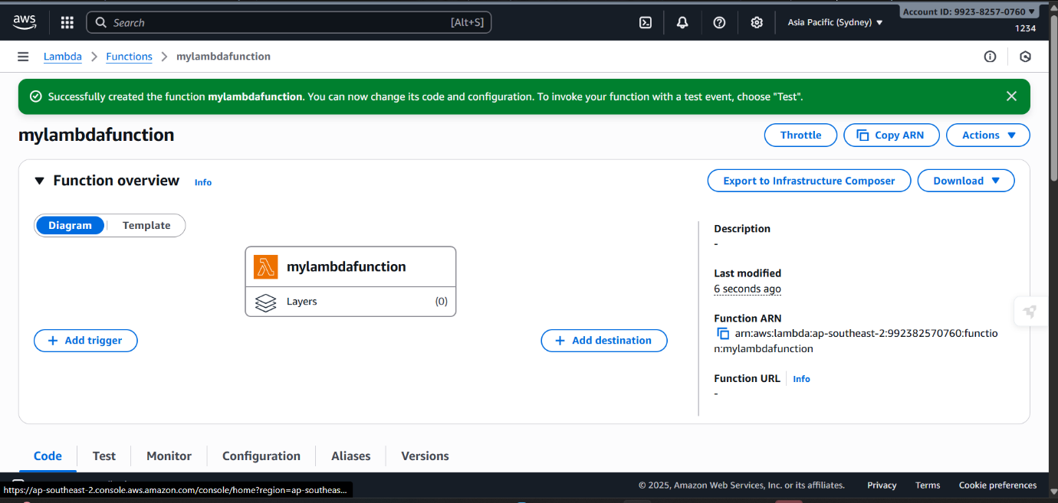

7. Add Your Code
- In the Function code section, you can:
  - Write inline code in the editor.
  - Or upload a .zip file.
  - Or use Amazon S3 (if your code is stored there).
Example default code in Python:
def lambda_handler(event, context):
return {
'statusCode': 200,
'body': 'Hello from Lambda!'
}
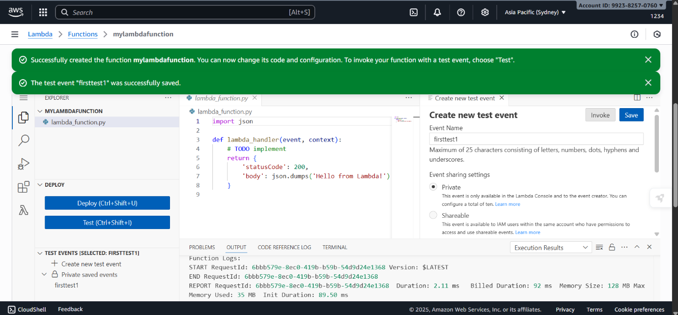

8. Configure Test Event
- Click Test → Configure test event.
- Give it a name (e.g., TestEvent).
- Keep the default event JSON or modify as needed.
- Save.

9. Run the Function
- Click Test again.
- Check the execution results (output, logs, and status).

10. (Optional) Add a Trigger
- You can connect Lambda to services like:
  - API Gateway (for REST APIs)
  - S3 (trigger on file uploads)
  - DynamoDB (trigger on database changes)
  - EventBridge (scheduled events)
